2-Week MS-AI/DS/CS/BA Project Guidelines

- Project Structure Overview
  - Total Marks: 30
  - Deadline: 30th of January, 2026
  - Failure to project key takeaways and compliances can affect final exam
  - Students who secure 80% and above will get marks reflection in their previous exams as well where percentages are below 80%
  - Key algorithms you can choose one from are
    - CRNNs
    - GCNNs, GRNNs
    - VAEs, CAEs
    - Transformers
  - Key domains to work with only are:
    - Veterinary
    - Agriculture
  - Accuracy below 75% carries zero marks
  - For the project's GitHub repository, you should include several key sections to effectively showcase a student's work.
    - Start with a clear project title and a concise abstract or overview explaining the problem being solved and the approach taken.
    - Follow this with an introduction that provides context, motivation, and the project's objectives. Include a section on the dataset describing its source, size, features, and any preprocessing steps applied such as cleaning, normalization, or augmentation.
    - The methodology section should detail the algorithms or models used, the rationale for choosing them, and the architecture if using neural networks.
    - Document your experimental setup including train-test splits, cross-validation strategy, hyperparameter choices, and the hardware or software environment used.
    - The results section is critical and should present performance metrics like accuracy, precision, recall, F1 score, or AUC-ROC depending on the task, along with visualizations such as confusion matrices, learning curves, or ROC curves.
    - Include a comparison with baseline models or benchmarks to contextualize your results.
    - Add a discussion section analyzing what worked, what didn't, challenges encountered, and lessons learned.
    - Provide clear installation and usage instructions so others can reproduce your work, along with a requirements file listing dependencies.
    - Finally, include a conclusion summarizing achievements and potential future improvements, references to papers or resources you drew upon, and acknowledgments if applicable.
    - A well-organized repository structure with separate folders for data, notebooks, source code, and results also demonstrates professionalism and makes the project easier to navigate.
  - Email Format: Presentation__FullName__RegNo__FALL2025
  - Email material should have the following documents:
    - Team’s Introduction - 4 lines for both students if working in group of 2
    - Project Documentation
    - Final Short Report
    - Github Commit History File with details
    - Project Repo as zip file
    - Github Link
    - Presentation File
    - Demo Video
  - Email Template:
Subject: [e.g. Presentation__ FullName__ RegisterationNumber__ FALL2025]

Hi [Professor/Instructor Name],

Please find below my submission for [Course Name/Project Name].
Project: [Title]
Short Summary: [write 5 sentence summary here]

Links:

Presentation:
GitHub:
Documentation:
Final Report:
Demo Video:

Technical Snapshot:
a. Team Details: [four lines about you & your team member]
b. Technique[e.g., ResNet-50 with fine-tuning]
c. Dataset[e.g., PlantVillage, 54k images, 38 classes]
d. Loss Function[e.g., Cross-entropy]
e. Evaluation Metrics[e.g., Accuracy: 96.2%, F1: 0.94]
f. Framework[e.g., PyTorch 2.0]
g. Key Contribution: [1-2 sentences on what makes your approach notable]
h. Learning Outcomes: [write at least 5]

Happy to discuss or demo further if needed.

Best regards,
[Your Name]
[Student ID]
[Email/Contact]
  - Weak Presentations can affect overall performance of the project, come prepared when instructed for giving project presentations
  - Students who will not update their progress on excel file will get zero marks
  - A well-organized 4-week AI project typically follows this timeline:
    - Week 1: Foundation & Planning
Define your problem statement clearly, gather and explore your dataset, and set up your development environment. Document your baseline approach and success metrics. This week should end with a working data pipeline.
    - Week 1: Model Development
Implement your initial model, run baseline experiments, and begin iterating. Focus on getting something working end-to-end before optimizing.
    - Week 2: Refinement & Experimentation
Improve model performance through hyperparameter tuning, feature engineering, or architecture changes. Compare multiple approaches and document what works and what doesn't.
    - Week 2: Polish & Presentation
Finalize your best model, create visualizations, write documentation, and prepare your presentation or demo. Ensure reproducibility.

- Key Takeaways with 20 Marks Distribution:
  - Project Documentation [Introduction, Objectives, Technology Benefits, Business Benefits, Project Timeline(Number of hours against tasks), Tech Stack] less than 5 pages (2.5)
  - Project Working Demo (7.5)
  - Project Github -- at least 20 commits (2.5)
  - Project Presentation [Introduction, Objectives, How its related to SDGs, Methodology, Demo Video, QnAs] (5)
  - Short Project Report [includes Literature Review of at least 10 research articles not older than 2024] (7.5)
  - Student's Attitude, Mindfulness & Awareness towards Project (5)

- How to Update Progress
  - Weekly Check-ins Should Include:
    - What was accomplished vs. what was planned
    - Current blockers or challenges
    - Key metrics and results (with visualizations)
    - Updated timeline if needed
    - Questions or areas where you need guidance

- Documentation Best Practices:
  - Maintain a project journal or log with dated entries
  - Track all experiments in a structured way (use tools like MLflow, Weights & Biases, or even a simple spreadsheet)
  - Version control your code with meaningful commit messages
  - Keep a "lessons-learned" section in the report and branch on github

- What to Avoid
  - Technical Pitfalls
    - Starting with overly complex models before establishing a baseline
    - Data leakage between training and test sets
    - Ignoring data quality issues and diving straight into modeling
    - Not setting aside a proper test set from the beginning
    - Overfitting to your validation set through excessive tuning
  - Project Management Issues
    - Scope creep—trying to add too many features mid-project
    - Spending too much time on data collection and leaving no time for modeling
    - Perfectionism—waiting too long to get something working
    - Poor documentation that makes your work hard to reproduce
    - Not having a backup plan if your main approach fails
  - Presentation Mistakes
    - Claiming results without proper validation
    - Ignoring ethical implications or biases in your data/model
    - Not explaining your work clearly to non-technical audiences
    - Overselling what your model can actually do

- What Makes a Project Exceptional
  - Technical Excellence
    - Clear problem formulation with well-defined success metrics
    - Rigorous experimental methodology with proper train/validation/test splits
    - Thoughtful comparison of multiple approaches with analysis of why one works better
    - Attention to edge cases and failure modes
    - Clean, well-documented, reproducible code
  - Creativity & Impact
    - A novel angle on an existing problem or an underexplored domain
    - Real-world applicability and clear use case
    - Consideration of ethical implications and potential biases
    - A working demo or deployment that people can interact with
  - Communication
    - Clear storytelling that explains the "why" behind your choices
    - Honest discussion of limitations and future improvements
    - Strong visualizations that convey insights effectively
    - Ability to explain technical details to different audiences
  - Going the Extra Mile
    - Deploying your model (even a simple web app or API)
    - Conducting user testing or getting feedback from domain experts
    - Analyzing failure cases and explaining when your model struggles
    - Contributing something back (open-source code, dataset, tutorial)

- MUST ADDRESS ONE OF THE FOLLOWING SDGs:
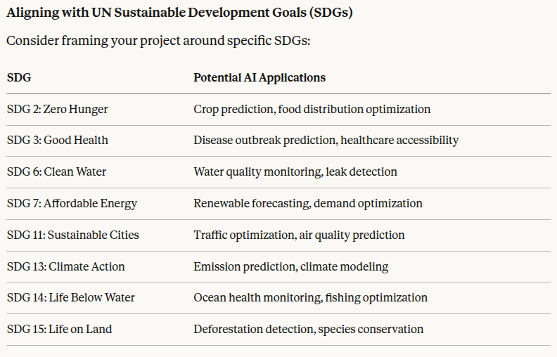

- Suggested Domains & Project Ideas (but you can come up with your own as well that maintains section 7):
  - Healthcare & Medical
    - Disease prediction from patient records or medical images
    - Drug interaction prediction
    - Mental health sentiment analysis from text
  - Natural Language Processing
    - Sentiment analysis for product reviews or social media
    - Text summarization or question-answering systems
    - Chatbot for a specific domain (customer service, education)
  - Computer Vision
    - Object detection for a specific use case (traffic, retail, agriculture)
    - Image classification (plant diseases, product defects)
    - Face mask or safety gear detection
  - Finance & Business
    - Stock price prediction or trend analysis
    - Customer churn prediction
    - Fraud detection system
  - Environment & Sustainability
    - Air quality prediction
    - Wildlife species identification
    - Energy consumption forecasting
  - Education
    - Student performance prediction
    - Automated essay scoring
    - Personalized learning recommendation system
  - Social Good
    - Accessibility tools (sign language recognition, image captioning for visually impaired)
    - Fake news detection
    - Disaster response optimization

